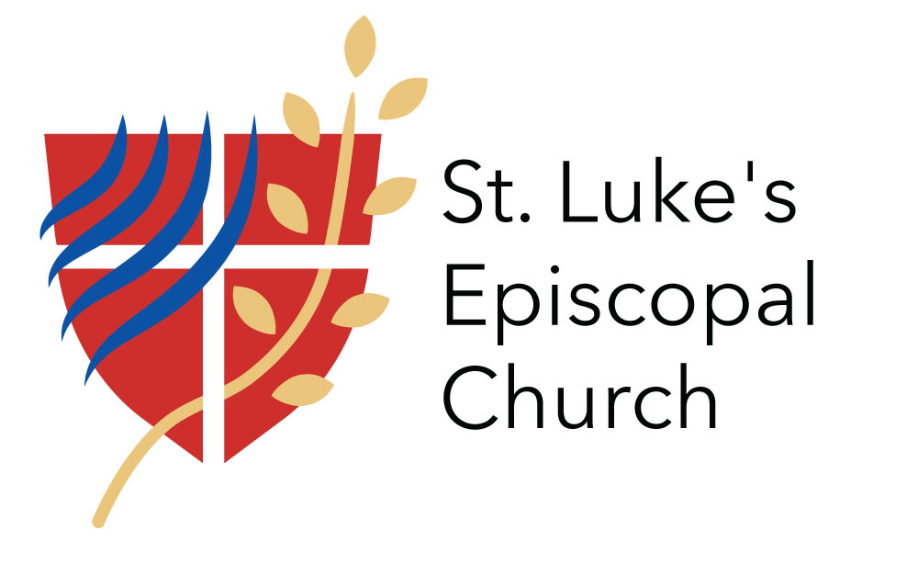
Office & Facilities Manager Job Description
St. Luke's Episcopal Church
Seattle, Washington
October, 2022

The Office & Facilities Manager, working with the Vicar, staff and congregational leaders, is responsible for church operations, coordination of tenants and upkeep of the facilities. The Office and Facilities Manager works to run an efficient and economical church office, produces various communication materials and keeps the church’s media updated.
Office Manager Responsibilities
- Answer the telephone and door, process the mail and respond to emails in a timely manner
- Maintain and update phone system and messages
- Work with Vicar, Wardens and Treasurer to complete the Annual Report, Parochial Report, Congregational Leadership Report and other required reports
- Ensure Safeguarding training certificates are kept current for all employees, volunteers, and buildings users required to have them. Schedule in-person trainings when needed.
- Supervise and coordinate all parish mailings, including support for the Stewardship Team, Edible Hope Kitchen and the Vicar
- Maintain parish database, directory, newsletter mailing list, and nametags
- Maintain accurate records of keys issued and ensure adequate supply of keys. Make keys available for staff, volunteers, renters and outside groups, as necessary
- Maintain petty cash
- Order office, altar, and janitorial supplies and other items as requested by ministry leaders
- Promptly submit all receipts, bills, and check requests to bookkeeper for recording/payment, with approval from ministry leaders as needed
- Maintains a list of services for those experiencing need and makes referrals as appropriate
- Maintain office files
Facility Manager Responsibilities
- Coordinate and oversee all building users and respond to their requests and concerns. Insure timely payment of building use fees and utilities as specified by agreement
- Ensure current insurance certificates are on file for all non-residential tenants
- Complete new tenant leases and review existing ones on an annual basis
- Negotiate and manage contracts with vendors and service providers to manage property, janitorial service, building upkeep and repairs, order supplies, and maintain equipment
- Meet/supervise contractors
- Manage parking arrangements, create and distribute permits as needed
- Communicate with the Caretaker and Groundskeeper in the maintenance and safety of the property and grounds
- Participate in monthly Health and Safety Team meetings
Communication Responsibilities
- Produce weekly bulletin and customary for in person and virtual worship
- Produce weekly online newsletter
- Update Facebook and other social media outlets with current events and resources
- Manage the parish website and online calendar
- Serve as the main contact for diocesan communications and communicator’s meetings
Parish Administrator Attributes
- Professionalism and confidentiality
- Ability to interact graciously and hospitably with a variety of people
- High level of accuracy and attention to detail
- Skill in managing vendors, contractors, building users and volunteers
- Experience with website and social media management and maintenance
- Skilled in a variety of computer software applications in word processing, spreadsheets, database, design and presentation software (Microsoft Office, Google, Realm, etc.)
- Ability to manage varied demands and priorities effectively
- Ability to plan, prioritize and work independently with limited supervision, establishing priorities and meeting deadlines

Office and Facilities Manager Requirements
- The Manager must attend Safeguarding God’s Children and Safeguarding God’s People training within the first three months of employment and obtain a certificate of completion. If the Manager has previously attended the training, s/he must provide documentation demonstrating completion. The Manager will conduct her/himself within the policies and guidelines established the Safeguarding training.
- The Manager must undergo a criminal background check as part of the hiring process.
- The Administrator should be able to lift 10-15 pounds and to access all the buildings and property.

Benefits:
- This position is governed by diocesan Personnel Policies and Procedures for Mission congregations as adopted by the Bishop’s Committee
- This is a non-exempt position. Wages will be adjusted based on an annual COLA as determined by Diocesan Convention

Application may be made by October 30, 2022
The Rev. Canon Britt Olson, britt@stlukesseattle.org
(206) 784-3119

